**How similar are the restaurant markets of Manhattan and Toronto**

1. **Introduction**
   1. **Background**

The market of Toronto is expanding as the population of Toronto growing. As a manager who runs a very successful restaurant in Manhattan, it is compelling to expand your business to Toronto. However, people in different areas have different tastes. And it is a good idea to evaluate whether the market in Toronto is similar to that in Manhattan before making entry decisions. Also, if you decide to enter Austin market, it is important to decide which neighborhood to enter. It is a rational to enter a market that is similar to the market you are at now to reduce the risk.

* 1. **Problem**

The problem is to find the correct market (neighborhood) to open a new restaurant. A restaurant that is successful in Manhattan might be more likely to be successful in Toronto if the new franchise is in a neighborhood that is similar to the old one. So, we would like to group neighborhoods in Manhattan and Toronto together so that neighborhoods in the same group are similar.

**1.3 Interest**

Obvious, people in the restaurant industry who plans to expand their business from Manhattan to Toronto, or from Toronto to Manhattan, would be interested.

1. **Data**

Data of Venus in Manhattan and Toronto is from Foursquare. It includes the location and the type of each Venue. The neighborhood location data for Manhattan is downloaded from <https://cocl.us/new_york_dataset>. . The neighborhood location data for Toronto is scrapped from <https://en.wikipedia.org/wiki/List_of_postal_codes_of_Canada:_M>.

1. **Exploratory Data Analysis**

In the following, I plot histograms shows the number of venues in Manhattan and Toronto neighborhoods. And from the histogram we could see that Neighborhoods in Manhattan have more Venues than neighborhoods in Toronto.

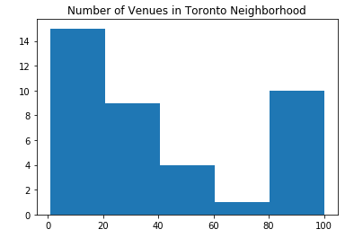

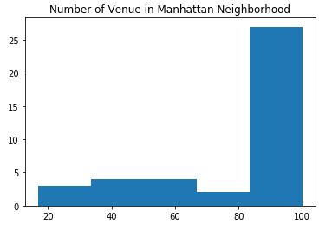

However, the number of venues only shows one aspect of the neighborhood. The composition of different types of venues in the neighborhood also matter.

1. **Methodology**

I use k-means clustering trying to group neighborhood together according to their characteristics. I set the number of cluster to 10 so that I could group all the neighbourhoods in a finer way.

1. **Result**

The following table shows how neighborhoods are grouped together.

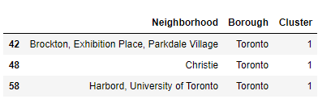

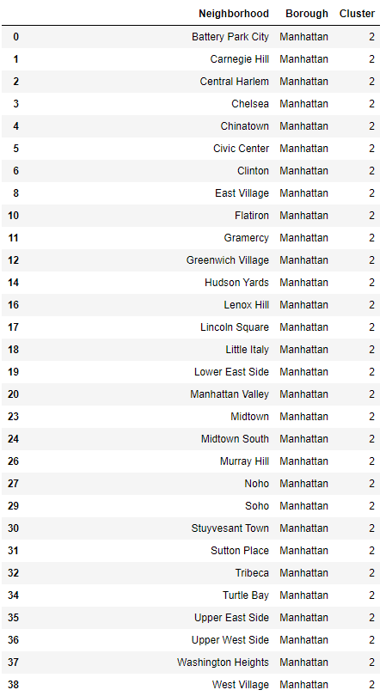

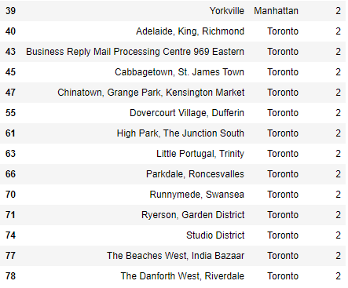



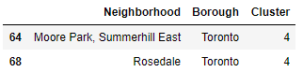

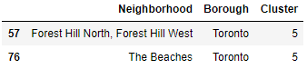





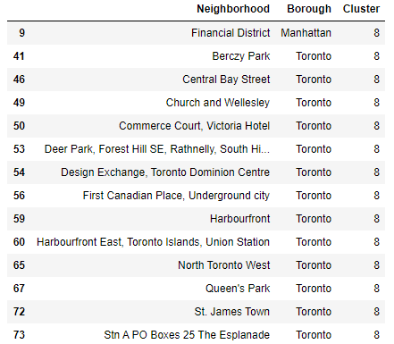

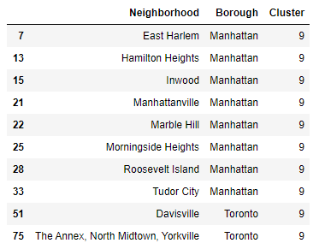

As we can see that Cluster 1,3, 4, 5, 6, 7 only contains neighborhoods in Toronto. Cluster 2, 8 ,9 contains neighborhoods from both Borough. If a resturant manager want to enter a new market, she should consider entering the neighborhood that is in the same cluster as her current resturant.

1. **Discuss**

From the result we can see that most neighborhood are clustered in cluster 2. If you would like to further divide neihborhood in cluster 2, you could do it by choosing more clusters. If we have more data that contains further information about the characteristics of each neighborhood, we might be able to cluster these neighborhood better.

**7.Result**

Resturant managers should consider entering the neighborhood that is in the same cluster because the market condition of markets in the same cluster are closer. Because it is more likely to be successful.